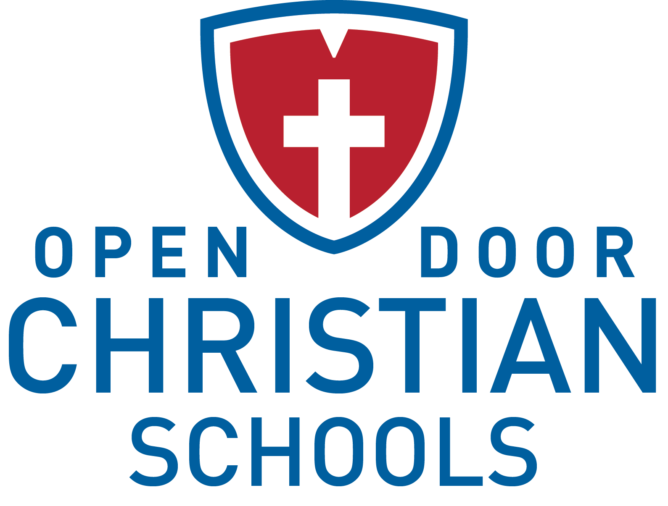

Admissions Coordinator
Employment Opportunity

Job Title: Admissions Coordinator
Reports To: Director of Admissions
Prepared Date: 03.2017

Position Overview
Open Door Christian Schools (ODCS) is seeking a part-time Admissions Coordinator for the 2017-2018 school year (with an earlier start date possible) who will be responsible for working directly with the Director of Admissions and Communications in overseeing and facilitating the admissions and enrollment processes.

Type of Position
The Admissions Coordinator position is a part-time, 12 month, nonexempt position that is paid an hourly rate. While actual hours per week will somewhat vary, the position is an average of approximately 28 hours per week.

Required Spiritual Qualities
- Has received and acknowledges Jesus Christ as his/her personal Lord and Savior.
- Seeks to live a life as His disciple.
- Stands as a positive Christian role model for students, staff and our larger community.
- Regularly attends church with a congregation that has a statement of faith consistent with the School’s statement of faith.
- Demonstrates by example the importance of the Scriptures in the daily life of a believer.
- Agrees and supports the ODCS Statement of Faith and Employee Lifestyle Statement.

Required Professional Qualities
- Holds, at a minimum, an Associate degree.
- Has prior experience working in an admissions role (preferred, but not required).
- Demonstrates a reasonable level of computer/software literacy to meet the demands of the position.
- Is organized and able to multi-task.
- Is highly motivated and can work independently with minimal supervision.
- Possesses good verbal and written communication skills.
- Maintains confidentiality of sensitive information.
- Promotes a positive attitude about the School and its employees and students.
- Agrees to abide by School policies and procedures.
- Commits to excellence, efficiency, customer service and the School’s shared values.

Essential Job Functions
- Inquiry management – Meets and tours inquiring families and answers questions whether in person or on the phone. Fills out paperwork for student shadow days. Enters new inquiring families into database.
- Admissions Follow-up – Supports the Director of Admissions and Communication as needed (i.e. follows-up with prospects and tracks status in admissions database).
- Admissions Database – Maintains current and accurate records.
- Applications – Receives and processes applications through completion.
- Acceptance – Facilitates acceptances.
- Re-enrollment – Works with Director of Admissions and Communications and Business Office to coordinate re-enrollment and process online re-enrollment packets.
- Open Houses – Coordinates all aspects of Open House events including setup/cleanup and coordination of tour guides, hostess and student ambassadors.
- Student Ambassadors – Recruits and trains student candidates that represent ODCS to prospective families during various events.
- Shadow Days – Coordinates calendars and appropriate student hosts for prospective student visits.
- Communications and Media
  - Promotional Materials – Helps create and distribute materials about ODCS at various events.
  - Website – Assists Director of Admissions and Communications in maintaining website.
  - Parent Portal – Maintains announcements and posts resource documents to online parent portal. Provides input for improved communications with staff and families.
  - Digital Street Sign –Updates street sign with current events and important news.
- General Support
  - Administrative Assistant – Provides various administrative assistance functions to the Director of Admissions and Communications.
  - Calendar and Processes – Works with the Director of Admissions and Communications to create an annual admissions calendar, helps to streamline processes and assists in revisions to procedures.
  - Upper School Office Support – Assists the Upper School Secretary with incoming phone calls and visitors as needed. Cares for and maintains a comfortable and workable office space.
- Performs other duties as assigned.

Contact Information
Interested candidates should submit a cover letter, resume and the Non-Certified Application (which may be found at odcs.org under “About” and then “Career Opportunities”) to:

Denver Daniel, President
Open Door Christian Schools, Inc.
8287 West Ridge Road
Elyria, OH 44035
denver.daniel@odsc.org

