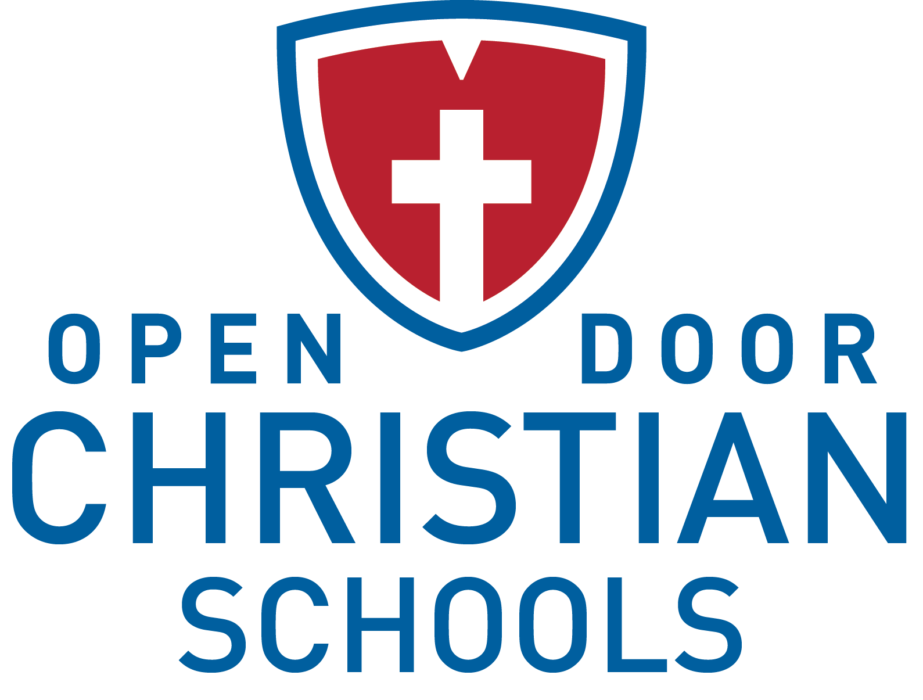

Director of Admissions & Communications
Employment Opportunity

Job Title: Director of Admissions & Communications
Reports To: President
Prepared Date: 03.2017

Position Overview
Open Door Christian Schools (ODCS) is seeking a full-time Director of Admissions & Communications for the 2017-2018 school year (with an earlier start date possible) who will be responsible for overseeing and facilitating the admissions and enrollment processes, as well as the communications and marketing functions. This position will also be part of the collaborative Administrative Team.

Type of Position
The Director of Admissions & Communications is a full-time, 12 month, exempt position that is paid an annual salary. In addition, benefits are offered.

Required Spiritual Qualities
- Has received and acknowledges Jesus Christ as his/her personal Lord and Savior.
- Seeks to live a life as His disciple.
- Stands as a positive Christian role model for students, staff and our larger community.
- Regularly attends church with a congregation that has a statement of faith consistent with the School’s statement of faith.
- Demonstrates by example the importance of the Scriptures in the daily life of a believer.
- Agrees and supports the ODCS Statement of Faith and Employee Lifestyle Statement.

Required Professional Qualities and Skills
- Holds a Bachelor’s degree with a major in marketing preferred.
- Has prior experience working in an admissions role.
- Has the ability, initiative and motivation to set and achieve goals and is results drive.
- Possesses sales skills by being professional, poised and polished.
- Has knowledge of and experience using web-based and social media marketing strategies.
- Demonstrates a high functioning level of computer/software literacy to meet the demands of the position.
- Is organized and able to multi-task.
- Is highly motivated and can work independently with minimal supervision.
- Possesses exceptional verbal and written communication skills and is very personable.
- Has passion for Christian school education and ODCS.
- Is able to lead, delegate to and supervise direct reports.
- Maintains confidentiality of sensitive information.
- Promotes a positive attitude about the School and its employees and students.
- Agrees to abide by School policies and procedures.
- Commits to excellence, efficiency, customer service and the School’s shared values.

Overall Job Functions
- Works closely with the President and Administrative Team on the development and implementation of the School’s marketing and communication plan.
- Focuses on developing and implementing lead generation strategies to provide interest in the School.

Marketing Functions
- Marketing Plan – Develops and implements a comprehensive marketing plan and strategy for the School.
- Internal Marketing – Develops and implements an internal marketing strategy to reinforce the School’s core brand messages and customer satisfaction to the parent community.
- Web-Based Marketing – Provides oversight and leadership to the School’s website by regularly updating the content. Acts as the Schools’ webmaster. Utilizes web-based marketing strategies to increase the online presence for the School including the effective use of social media sites and search engine optimization.
- External Marketing – Develops and implements an external marketing effort that generates increased awareness for the School within all of its target constituencies including parents, faculty/staff, grandparents, alumni, donors and friends, as well as within the community.
- Events – Provides event leadership for admissions, retention and marketing including open houses, re-enrollment, etc.
- Branding – Provides leadership to the School community for the ODCS brand by enforcing brand standards as well as reviewing and approving all collateral and web-based communications.

Communications Functions
- Internal Communications – Provides a consistent, timely and compelling flow of communication to current parents through the use of mailings, School website, social media, emails and other strategies.
- External Communications – Provides a regular flow of external marketing communications to all constituent groups through the use of mailings, School website, social media, emails and other strategies.
- Story Telling – Communicates the ODCS “story” through effective writing and speaking. Provides leadership for the School in crafting these stories and communicating them throughout various outlets.
- Editor – Acts as editor to various communications such as flyers, school-wide letter, The Patriot Voice and others.

Public/Community Relationships Functions
- Media Relations – Develops relationships with and provides press releases to the media to promote ODCS to the community.
- Public Relations – Acts as main spokesperson, along with the President, for ODCS in all communications to the public.
- Community Relations – Develops and implements a plan for School presence at events within the community.

Admissions Functions
- School Representative – Serves as point of first contact for any inquiring family.
- Lead Nurturing – Oversees lead nurturing efforts including tours, shadows, open houses, informational meetings and follow-up calls/emails.
- Application Process – Ensures the application process progresses efficiently (i.e. procuring references, overseeing the administration of screenings or tests, coordinating the family interview, etc.)
- Admissions Materials – Oversees creation and production of all admissions materials such as applications, brochures, school profiles, test results and tuition/tuition assistance information.
- Policies and Procedures – Authors, revises and implements policies and procedures for all functions pertaining to or connected with the Office of Admissions.
- Trend and Dashboard Analyses – Gathers, maintains and analyzes data (i.e. current enrollment, new students, applicants, hot prospects, inquiries, visits, withdrawal reasons, etc.) to assist School leadership in making decisions.
- International/Foreign Exchange Students – Manages the entire international admissions process.

Re-Enrollment and Retention Functions
- Admissions Committee – Leads team of staff and parents to develop plan and strategies to reach retention goals each year.
- Process Development – Coordinates the re-enrollment process including developing the timeline, building the online process, printing materials and working with the Business Office on related efforts.
- Communications – Communicates with families to ensure they are informed of the re-enrollment process and related information.
- Withdrawal Coordination – Coordinates potential withdrawal situations by first trying to resolve any concerns that may allow the student to remain at ODCS and initiating the formal withdrawal process and exit interview if student does withdraw.

Alumni Functions
- Alumni Relations and Events – Develops strategies for cultivating alumni relations, including the planning of various alumni events.
- Maintaining Databases – Maintains databases for alumni information.

Other Functions
- Performs other duties as assigned.

Contact Information
Interested candidates should submit a cover letter, resume and the Administrator Application (which may be found at odcs.org under “About” and then “Career Opportunities”) to:

Denver Daniel, President
Open Door Christian Schools, Inc.
8287 West Ridge Road
Elyria, OH 44035
denver.daniel@odsc.org

