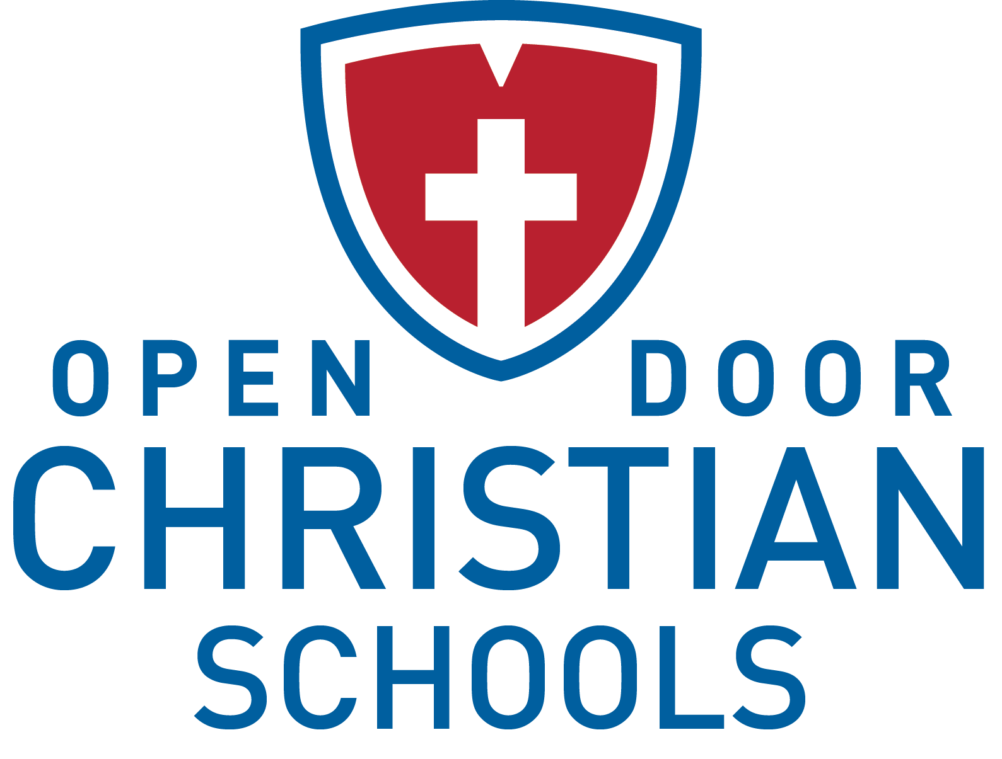

Upper School Science Teacher
Employment Opportunity

Job Title: Upper School Science Teacher (grades 7-12)
Reports To: Upper School Principal
Prepared Date: 11.2016

Position Overview
Open Door Christian Schools has an immediate opening for a full-time Upper School Science teacher who will be responsible for teaching science courses at the upper school level (grades 7-12). Teacher will be a mature believer who embraces the mission of the School, which is to equip disciples through exemplary education.

Type of Position
The Upper School Science Teacher (grades 7-12) position is a full-time, exempt position that is paid an annual salary commensurate with experience and degree(s) held. In addition, benefits are offered.

Required Spiritual Qualities
- Has received and acknowledges Jesus Christ as his/her personal Lord and Savior.
- Seeks to live a life as His disciple.
- Stands as a positive Christian role model for students, staff and our larger community.
- Regularly attends church with a congregation that has a statement of faith consistent with the School’s statement of faith.
- Demonstrates by example the importance of the Scriptures in the daily life of a believer.
- Agrees and supports the ODCS Statement of Faith and Employee Lifestyle Statement.

Required Professional Qualities
- Holds, at a minimum, a Bachelor’s degree from an accredited postsecondary institution.
- Holds an ACSI certificate or is willing to complete the requirements for certification within a specified time period.
- Holds an Ohio Department of Education (ODE) teaching credential or is willing to complete the requirements for certification within a specified time period.
- Demonstrates a reasonable level of computer literacy and is willing to integrate technology into the classroom.
- Promotes a positive attitude about the School and its employees and students.
- Agrees to abide by School policies and procedures.
- Commits to excellence, efficiency, customer service and the School’s shared values.

Essential Job Functions
- Invests in the lives of students to motivate them to grow in their faith and, for those students who are not saved, to accept God’s gift of salvation through Jesus Christ.
- Works with the administration and staff to address the spiritual formation needs of the students.
- Has a thorough knowledge and understanding of the Christian philosophy of education.
- Integrates biblical principles and the Christian worldview throughout the curriculum and activities.
- Teaches classes as assigned following the prescribed scope and sequence as scheduled by the administration.
- Is familiar with the process of, refines and revises curriculum mapping.
- Diagnoses the learning needs of all students on a regular basis and uses differentiated teaching methods to reach all types of student learners.
- Challenges high-performing students to achieve greater academic success, while providing remedial instruction to struggling students.
- Plans broadly through the use of semester lesson plans and objectives, and more currently through the use of RenWeb Student Information System.
- Uses homework effectively for drill, review, enrichment or project work.
- Regularly assesses the learning of students.
- Enters grades into RenWeb Student Information System and provides progress reports as required by School policy.
- Effectively manages the classroom to provide an environment for learning and to ensure the protection of students, equipment, materials and facilities.
- Maintains a clean, attractive and organized classroom.
- Maintains adequate hours outside of the school day for tutoring students.
- Responds in a timely and professional manner to parent communications.
- Maintains confidentiality of student information.
- Participates in continuous professional development through professional reading, college course work in-services, workshops and conferences.
- Accepts share of assigned duties outside of instructional classroom duties.
- Attends meetings, chapels, prayer times and Bible studies as required.
- Performs other duties as assigned.

Current Upper School Science offerings to be taught include the following:
- Science Grade 7
- Biology/Honors Biology
- Honors Chemistry
- Honors Physics

Contact Information
Interested candidates should submit a cover letter, resume and the Certified Teacher Application (which may be found at odcs.org under “About” and then “Career Opportunities”) to:

Denver Daniel, Head of Schools
Open Door Christian Schools, Inc.
8287 West Ridge Road
Elyria, OH 44035

denver.daniel@odcs.org

